===================================================================================
Nama: ahmad rafli firman rosyadi
Email : ahmadrapli70@gmail.com
No : 081334185032
Link linkedin : https://www.linkedin.com/in/ahmad-rafli-firman-rosyadi-384377145/
===================================================================================

How To Install HEAVY.AI Documentation

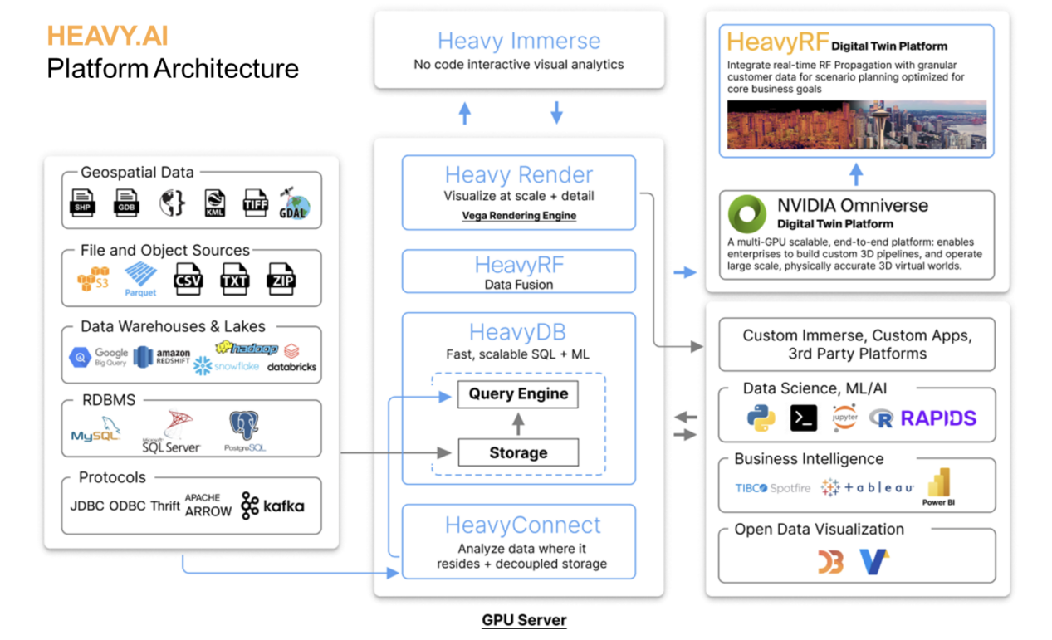

- Create user

sudo useradd --user-group --create-home --group sudo heavyai
sudo passwd heavyai
sudo su - heavyai

- Install file tar Heavy.AI

https://docs.heavy.ai/installation-and-configuration/installation/installing-on-ubuntu/centos-yum-gpu-ee

- extract the contents of the downloaded file

tar -xvf heavyai-ee-latest-Linux-x86_64-cpu.tar.gz

- Move the Binary Files

sudo cp -r /home/heavy/heavyai-ee-7.2.2-20231215-48e475359e-Linux-x86_64-cpu/* /opt/heavyai/

- Run script on package
(./opt/heavyai/install_heavy_systemd.sh)

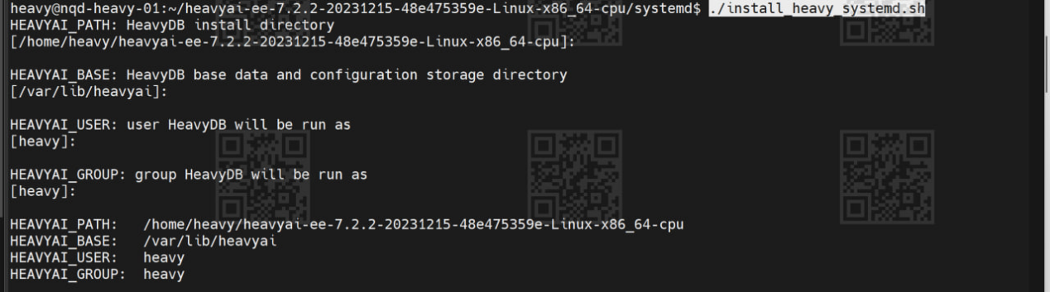

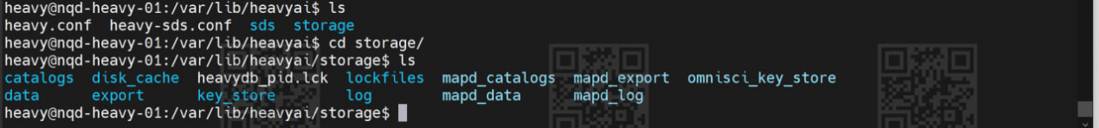
*The script creates a data directory in $HEAVYAI_BASE/storage (default /var/lib/heavyai/storage) with the directories catalogs, data, export and log.The import directory is created when you insert data the first time. If you are HEAVY.AI administrator, the log directory is of particular interest.

- Start and use HeavyDB and Heavy Immerse
sudo systemctl enable heavydb --now
sudo systemctl status heavydb
sudo systemctl start heavydb.service

sudo systemctl status heavydb.service

- Final Checks

/opt/heavyai/bin/heavysql

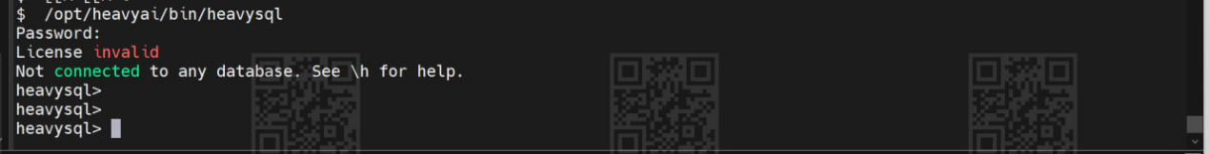
- Configurasi firewall
sudo ufw disable
sudo ufw allow 6273:6278/tcp
sudo ufw enable

- Link daskhboard untuk heavy ai
http://10.54.18.166:6273/heavyai/dashboards
